|  |  |
| --- | --- |
| 2016 | **Software Engineering Project 2**  **(Web Programming)**  **Fall-2016 (Section A)** |
|  | Daffodil International University |

***Submitted by***

Dewan Imtiaz Been Emran  
ID: 132-35-492

Md. Nafiul Islam

ID: 132-35-497

|  |
| --- |
| **[Documentation]** |
| ***Rental House Management System*** |

***Submitted To***

Asif Khan Shakir

Lecturer

Dept. of SWE

Abstract

* Our project “**Rental House Management System**” is related to online application of real estate.
* **Rental House Management System** is advanced solution for house rent problem.
* User shows all the properties of clients that are secure and verify & send them for the response.
* Here registration is also free of cost. So user can registration by using the System then rent the property & verify them. After few hours or days our guys put the property solution.
* For such complex process we provide a one simple online form which require your basic information and we will assist in sort time period.

The software is so reliable to user .Our main concept is give best & quick result to user.

Table of Content

1. Introduction 01

1.1 Background 01

1.2 Problem Definition 02

1.3 Existing System 02

1.4 Project Purpose 02

1.5 General Objectives 02

1.6 System Objectives 03

1.7 Project Scope 03

1.8 Project Goals 03

2. Literature Review 04

2.1 Government Strategy and Incentives in Housing Sector 04

2.2 The Role of the Private Sector in Housing Management 04

3. Requirement Analysis 05

3.1 Feasibility Study 05

3.2 Functional Requirement 05

3.3 User Requirements 06

3.4 Non-Functional Requirement 06

4. System Requirement Specification 07

4.1 Scope 07

4.2 Actor 07

4.3 Raw Requirement 07

4.4 Assumptions and Constrains 08

4.5 Dependencies and Risks 08

4.6 Hardware Specification 09

4.7 Software Specification 09

4.8 Server Specification 09

5. Diagram Representation 10

5.1 Flow-Chart 10

5.2 Use-Case 11

5.3 E-R Diagram 12

6. Implementation 12

6.1 Technology Use 12

6.2 Code Implementation 12

6.2.1 Routes 13

6.2.2 Search Controller 15

6.2.3 Edit and Delete Controller 16

6.2.4 Property Registration 17

6.2.5 Migration Design 19

7. Testing 20

7.1 White Box Testing 20

7.2 Black Box Testing 20

7.3 Test Cases 21

8. Result 22

8.1 Some Screenshots of the website 22

8.1.1 Index Page 22

8.1.2 House Category Sample 23

8.1.3 A Sample of Property Search by Area 23

8.1.4 No Property Found Page 24

8.1.5 Property Registration 24

8.1.6 User Registration 25

9. Conclusion and Discussion 25

10. References/Bibliography 26

1. **Introduction**

**1.1 Background:**

Housing has a central importance to quality of life with considerable economic, social, cultural and personal significance. Housing plays a huge role in revitalizing economic growth in any country, with shelter being among key indicators of development. The focus of this project is basically managing housing for low income, medium and high incomes households or what is commonly known as affordable housing. Most families choose to rent houses based on their income and family situations; the demand for rental houses is extremely high and more rental houses need to be put in place. Developing rental houses comes with many advantages especially to the house owners who are able to increase their profits through rent paid by the tenants. Increased number of tenants and house owners makes management difficult especially for the house owners who are losing huge sum of money through tenants who evade rent. The above statement gives a clear declaration as to why house rental agency management system need to be developed.

**1.2 Problem Definition:**

This is a basic system that will keep record of housing properties available on rent or for sale, and will work as connecting bridge between customer and property sellers.

Due to this system there is no need to visit various places in search of desired property. The information of various properties in various locations can be accessible at one place.

This system will provide a platform to home line property sellers and buyers. This will keep record of land, houses or flats available for sale or on rent with their rates and make this available to customers. Also will keep record of contact information of customer and will send necessary notices and/or reminders to customer.

**1.3 Existing System:**

Every year the company is designing new apartments and it’s a difficult task to manage the records of each and every apartment in the manual system. It will not only take a lot of time but it also increases the chances of errors. Sometimes even after repeated cross checks errors are found which lead to wrong calculation of accounts and balance sheet. It creates a problem when you need details of any particular project. All these problems lead to the rise of an alternative option.

**1.4 Project purpose:**

This website is an Online House renting business website through which a user can access its information and manage all the adding, updating, and deleting the assets and some of its tasks.

The Admin user can change the update the information regarding property selling and buying and cancellation. The system is very useful for the companies who develop apartments, hotels, villa, residential properties and commercial properties. Companies or individual agents can also advertise their property.

**1.5 General Objectives:**

Rental House Management System will be web based system. The house rental agency manages property for rent in Dhaka. Clients who wish to rent a property will register with the agency. They will provide personal details and information about the property type that they want. House owners will also register with the agency, providing their property details and personal details require for rent. Registered client will be able to see the available properties from the agency site. If any property match with his requirement, the client will inform the agency and the agency will manage the letting contract between the client and house owner. After the completion of the contract, the agency will get the commission from the house owner.

**1.6 System Objectives:**

* Each House owner can know information about the clients before signing the lease to know if there is any unpaid money or something negative issues.
* Each House owner is linked with website and share information in the distributed data base.
* Each House Owner can query about Tenant to know the unpaid batches or the time of the renewal contract.

**1.7 Project Scope:**

The project scope defines the description of the work that is required in delivering the rental house or house for sell which will be provided by this system. The following are the scopes of work during the course of the project:

* Study and understand the requirement of this project.
* Construct Software Requirement Specification document of the system.
* Construct Software Design Document of the system.

**1.8 Project Goals:**

* **Planned approach towards working**: The working in the organization will be well planned and organized. The data will be stored properly in data stores, which will help in retrieval of information as well as its storage.
* **Accuracy**: The level of accuracy in the proposed system cannot be decided. Because here user buy and another user build the home. There is no guarantee.
* **Reliability**: The reliability of the proposed system will be high due to the above stated reasons. The reason for the increased reliability of the system is that now there would be proper storage of information.

**2. Literature Review**

Literature review is a text written by someone to consider the critical points of current knowledge including substantive findings as well as theoretical and methodological contributions to a particular topic. Main goals are to situate the current study within the body of literature and to provide context for the particular reader.

**2.1 Government Strategy and Incentives in Housing Sector:**

Some of the dominant strategies for housing and service provision for the urban poor include slum upgrading and site and service schemes. However, the efficiency of these strategies has been limited by ambivalent government attitude to irregular settlement. These strategies have failed because of a reliance on inappropriate building by-laws and infrastructural standards and modern designs, construction technology and conventional building materials that all make housing unaffordable to the poor, even after subsidies. Thus, government initiatives in assisting house owners in management have proven to be pathetically slow with many of the houses provided being economically and socially irrelevant, this further prompting the rise of informal settlement.

**2.1 The Role of the Private Sector in Housing Management:**

Private sector housing management is defined as any process which is not connected at all with the actions of the state neither directly constructed by state nor financially sponsored by the state where production is not expected to have a social element.

The private sector can play an important role in housing provision provided that the state offers sufficient and appropriate incentives to the sector.

The clear motivation that underlies the private sector is profit (or potential profitability) with profit maximizing options being in the context of housing, producing and selling more of the product; reducing the cost of production through lower raw material and wage costs and finally increasing the price of the product or service.

**3. Requirement Analysis**

**3.1 Feasibility Study:**

The goal of every property developer is to achieve the maximum potential or highest best possible use for the development. In other words, realizing the best possible profit they can extract from a development site.

In order to make sure that the development project provides a certain level of profit, a financial feasibility study is undertaken during the initial due diligence phase. The sole purpose of this study is to determine the numbers and to evaluate a return from the development.

It looks into cash flow (the amount of money left after all expenses and costs have been paid) and equity (developer’s money left remaining after paying interests and borrowings).

Usually a preliminary property development feasibility study is done on a ‘per lot / per unit’ basis where by the profits and expenses are bifurcated on individual property basis.

**3.2 Functional Requirement:**

This is a necessary task, action or activity that was accomplished. The proposed system is able to:

* Allow administrator to add a houses, tenant and defaulters details.
* Allow the administrator to delete houses, tenants and defaulters details.
* Allow the administrator to search data in the database.
* Allow the administrator to edit data in the database.

In short, main functional requirement will be…

* Register.
* Log-in/log-out
* Keep clients record.
* Add property details.
* Provide the list of properties with necessary information.
* Special offers.
* Create/Update/Delete property details.
* Search property.

**3.3 User Requirements:**

It entailed user involvement and statements of facts and assumptions that define the expectations of the system in terms of mission objectives, environment, constraints and measures of effectiveness and suitability. Basically the users:

* A system that improves on the efficiency of information storage and retrieval.
* A system that is easy to learn and use.
* A system that is fast in processing transactions.
* A system that is flexible, safe and convenient.

**3.4 Non-Functional Requirement:**

* Improve the search facility and all users of property management system should get all the information in a second.
* The application should support the capability to use multi user environment.
* Display search result in one second.
* Update the list every hour.
* System should be available 24*7.

**4. System Requirement Specification**

**4.1 Scope:**

The real of World Wide Web have spread across millions of household, so naturally, Internet has become by far the best platform for real estate marketing today.

Now a days when everything is online, how is it possible that real estate left web application behind? There are lots of house rent companies who advertise their property online so idea behind developing this application is that their property can also sell, or buy or even rent property using this. These applications are not widely popular but in future, they have large scope of growth.

This website is an online house rental management system through which individual agents or house owner can maintain their property document keeping and managing property registration and also access its information and manage all the adding, updating, deleting the ads and some of its tasks. The Admin user can inform their house owner for regarding to property and update the information regarding property and cancellation of property or changing buyer choice.

The system is very useful for the companies or builders that can post and edit the information of their properties and their personal info and admin can monitor records of all of them.

**4.2 Actor:**

* Agency.
* House Owner
* Client

**4.3 Raw Requirement:**

* The house rental agency manages property for rent and properties are registered with the agency.
* House owners register their properties providing their details and information about the property.
* Clients who wish to rent a property will register with the agency and they can see the available properties from the agency site.
* Agency will provide personal details and other information about property to clients.
* The clients will inform the agency if any property match with their requirement.
* Agency will manage the letting contract between the client and house owner and after the completion of the contract agency will get the commission from house owner.

**4.4 Assumptions and Constrains:**

The assumptions and constrains could be briefly described as below:

**Accounting:** Especially when multiple properties are involved, people might not even realize that inaccurate or less-than-timely accounting processes are taking place. The lost productivity and issues that follow errors in data entry can add up quickly, hindering the bottom line.

**Maintenance management:** From scheduling and oversight to the actual walkthroughs that need to take place to ensure facilities are up to par with clients’ expectations, there should always be a method in place to track and handle these matters.

**Feedback response:** This one is critical to ensure long-term engagement and happiness among clients, as slow responses to feedback, criticism or requests can lead to poor retention. If there is no strategy in place, no method to your madness, you might want to rethink your approach.

**Without any error:** The code should be free with compilation errors/syntax errors.

**GIU:** The product must have an interface which is simple enough to understand.

**4.5 Dependencies and Risks:**

All users must have web access in order to use the system. Web security will be more concern of the project. Database design will be also a great challenge due to prevention of Sql Injection. Guest users and anonymous aren’t allowed to enter in the database will be the main challenge. Run of the project mainly depends on hardware of the server. Also user should have enough knowledge about internet browsing and can use such a device by which he/she may access.

* All necessary hardware and software are available for implementing and use of the tool.
* The proposed system would be designed, developed and implemented based on the SRS document.
* End users should have basic knowledge of computer and we also assure that the users will be given software training documentation and reference material.
* The system is not required to save generated reports.

**4.6 Hardware Specification:**

* Processor 2.0 Ghz processor speed or higher
* Memory 2GB RAM
* Visual Display Unit 800*600 colors

**4.7 Software Specification:**

* Operating System- windows 7 or higher
* Linux distribution

**4.8 Server Specification:**

* Processor2 x 1.6 GHz CPU
* RAM 3.5 GB RAM
* HDD 1x 40 GB of free space or more is recommended for the software that is listed in the software requirements (system drive)

**5. Diagram Representation**

**5.1 Flow-Chart**

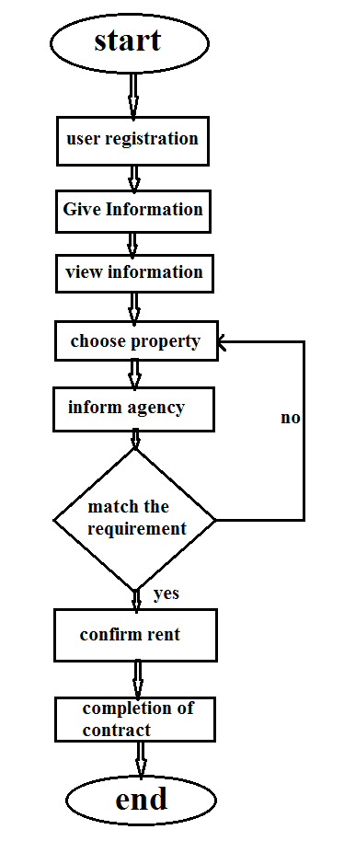

**5.2 Use-Case:**

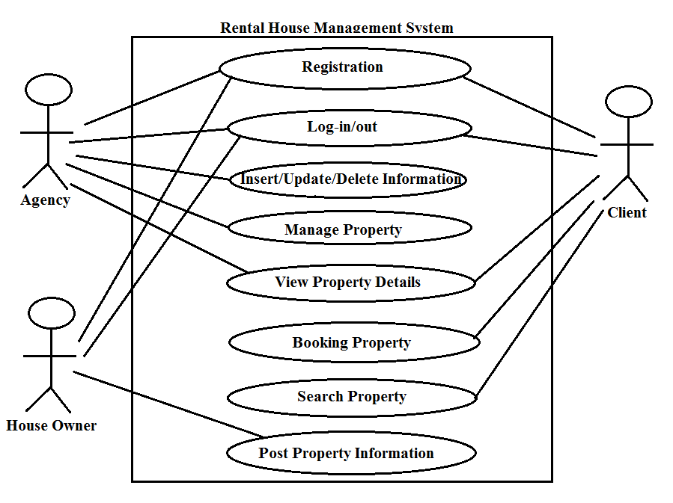

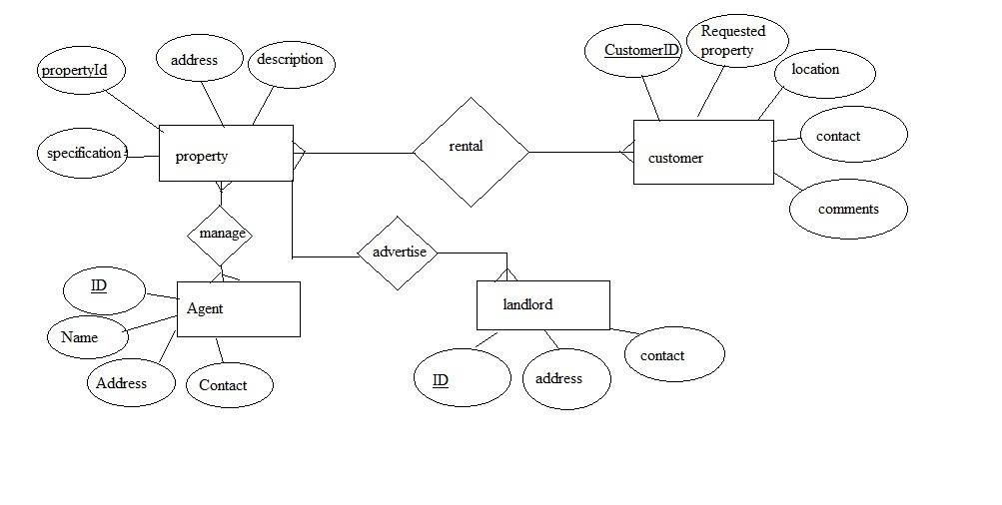**5.3 E-R Diagram:**

**6. Implementation**

**6.1 Technology Use:**

* HTML
* Bootstrap(Update)
* CSS
* PHP (Laravel)
* MySql (Database)

**6.2 Code Implementation:**

**6.2.1 Routes**

Route::resource(‘userlist’,’usercontroller’);

Route::get(‘/’, function () {

return view(‘homeland.index’);

});

Route::resource(‘property’,’propertyController’);

Route::resource(‘allproperty’,’propertyview’);

Route::resource(‘results’,’searchresult’);

Route::get(‘/’, function () {

return view(‘homeland.index’);

});

Route::get(‘/single-flat’, function () {

return view(‘areas.single-flat’);

});

Route::get(‘/duplex’, function () {

return view(‘areas.duplex’);

});

Route::get(‘/single-room’, function () {

return view(‘areas.single-room’);

});

Route::get(‘/holiday’, function () {

return view(‘areas.bunglow’);

});

Route::get(‘/bunglow’, function () {

return view(‘areas.bunglow’);

});

Route::get(‘/dhanmondi’, function () {

return view(‘areas.dhanmondi’);

});

Route::get(‘/mirpur’, function () {

return view(‘areas.mirpur’);

});

Route::get(‘/banani’, function () {

return view(‘areas.banani’);

});

Route::get(‘/gulshan’, function () {

return view(‘areas.gulshan’);

});

Route::get(‘/uttara’, function () {

return view(‘areas.uttara’);

});

Route::get(‘/motijheel’, function () {

return view(‘areas.motijheel’);

});

**6.2.2 Search Controller**

<?php

namespace App\Http\Controllers;

use Illuminate\Http\Request;

use App\Http\Requests;

use App\property;

class searchresult extends Controller

{

public function index(Request $request){

$alldata = property::orderBy(‘propertyaddress’);

$propertyaddress = $request -> input(‘propertyaddress’);

if(!empty($propertyaddress)){

$alldata->Where(‘propertyaddress’,’LIKE’,’%’.$propertyaddress.’%’,’or’,’region’,’LIKE’,’%’.$propertyaddress.’%’);

}

$alldata=$alldata->paginate(4);

return view(‘results.index’,compact(‘alldata’,’propertyaddress’));

}

}

**6.2.3 Edit and Delete Controller**

<?php

namespace App\Http\Controllers;

use Illuminate\Http\Request;

use App\Http\Requests;

use App\property;

class propertyview extends Controller

{

public function index(){

$alldata = property::paginate(4);

return view('propertyview.index',compact('alldata'));

}

public function edit($id){

$edata = property::findOrFail($id);

return view('propertyview.edit',compact('edata'));

}

public function update(Request $request, $id){

$input = $request->all();

$data = property::findOrFail($id);

$data ->update($input);

return redirect('');

}

public function destroy($propertyID){

$data = property::findOrFail($propertyID);

$data ->delete();

return redirect('');

}

}

**6.2.4 Property Registration**

<?php

namespace App\Http\Controllers;

use Illuminate\Http\Request;

use App\Http\Requests;

use App\property;

class propertyController extends Controller

{

public function index(){

return view('property.create');

}

public function store(Request $request)

{

/*$input = $request ->all();

property::create($input);

return redirect('property');*/

$logo = $request->file("image");

$upload = 'uploads/img';

$filename = $logo->getClientOriginalName();

$success = $logo->move($upload, $filename);

if($success){

$table = new property;

$table->propertyaddress = $request->input('propertyaddress');

$table->region = $request->input('region');

$table->bed = $request->input('bed');

$table->bathroom = $request->input('bathroom');

$table->sqft = $request->input('sqft');

$table->price = $request->input('price');

$table->description = $request->input('description');

$table->image = $filename;

$table->save();

}

}

}

**6.2.5 Migration Design**

<?php

namespace App;

use Illuminate\Database\Eloquent\Model;

class property extends Model

{

protected $table = "property";

protected $primaryKey = "propertyID";

protected $fillable = ['propertyaddress',

'region',

'bed',

'bathroom',

'sqft',

'price',

'description',

'image'];

}

**7. Testing**

Is it possible to invoke each menu function using logical assumptions that if all parts of the system are correct, the goal will be successfully achieved? In adequate testing or non-testing

will leads to errors that may appear few months later. That’s why it is very important to always test the new system. This create two problems the purpose of the system testing is to consider all the likely variations to which it will be suggested and push the systems to limits. The testing process focuses on the logical intervals of the system ensuring that all statements have been tested and on functional interval is conducting tests to uncover errors and ensure that defined input will produce actual results that agree with the required results. Program level testing, modules level testing integrated and carried out. There are two major type of testing they are

* White Box Testing.
* Black Box Testing.

**7.1 White Box Testing**

White box sometimes called “Glass box testing” is a test case design that uses the control structure of the procedural design to drive test case. Using white box testing methods, the following tests were made on the system.

* All independent paths within a module have been exercised once. In our system, ensuring that case was selected and executed checked all case structures. The bugs that were prevailing in some part of the code where fixed
* All logical decisions were checked for the truth and falsity of the values.

**7.2 Black Box Testing**

Black box testing focuses on the functional requirements of the system. This is black box testing enables the software engineering to derive a set of input conditions that will fully exercise all functional requirements for a program. Black box testing is not an alternative to white box testing rather it is complementary approach that is likely to uncover a different class of errors that white box methods like..

* Interface errors
* Performance in data structure
* Performance errors
* Initializing and termination errors

**7.3 Test Cases**

* **Unit Testing**: This is the lowest level of testing that is conducted to remove syntax & logic errors from a single unit. Individual components are tested to ensure that they operate correctly. Each component is tested independently, without other system components.
* **Module testing**: A module is a collection of dependent components such as an object class, an abstract data type or some looser collection of procedures & functions. A module encapsulates related components, so can be tested without other system modules.
* **Sub-System testing**: This phase involves testing collections of modules, which have been integrated into sub-systems. This tests for problems that arise from component interactions. This testing should begin as soon as usable versions of some of the system components are available.
* **System testing**: The sub-systems are integrated to make up the system. The system as a complete entity is tested over here. This process is concerned with finding errors that result from unanticipated interactions between sub-systems. It is also concerned with validating that the system meets its functional & non-functional requirements & testing the emergent system properties.
* **Acceptance testing**: This is the final stage in the testing process before the system is accepted for operational use. The system is tested with data supplied by the system customer rather than simulated test data. Acceptance testing may reveal errors & omissions in the system requirements definition because the real data exercise the system in different ways from the test data. It may also reveal requirements problems where the system’s facilities do not really meet the user’s needs or the system performance is unacceptable.

**8. Result**

**8.1 Some Screenshots of the Website**

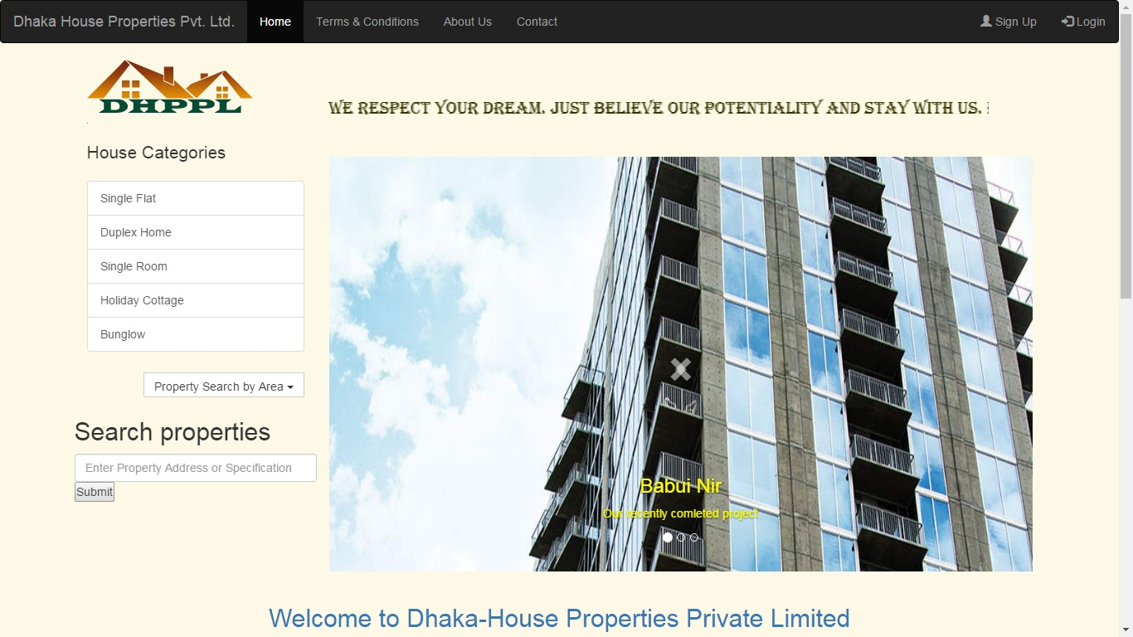**8.1.1 Index Page:**

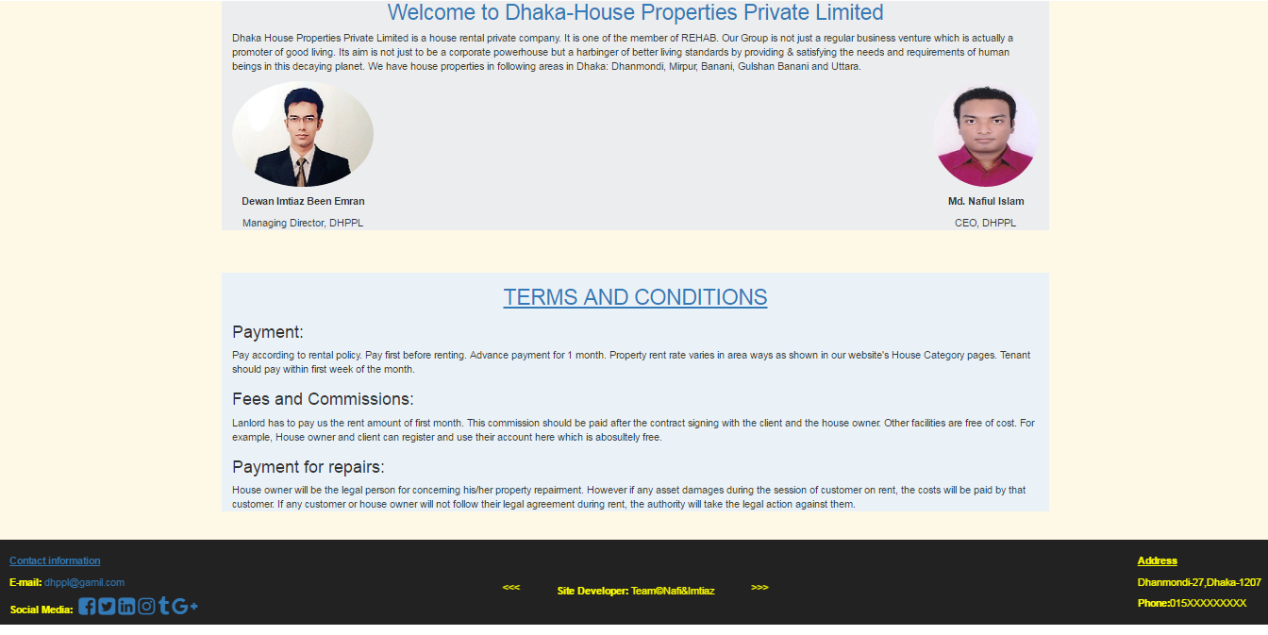

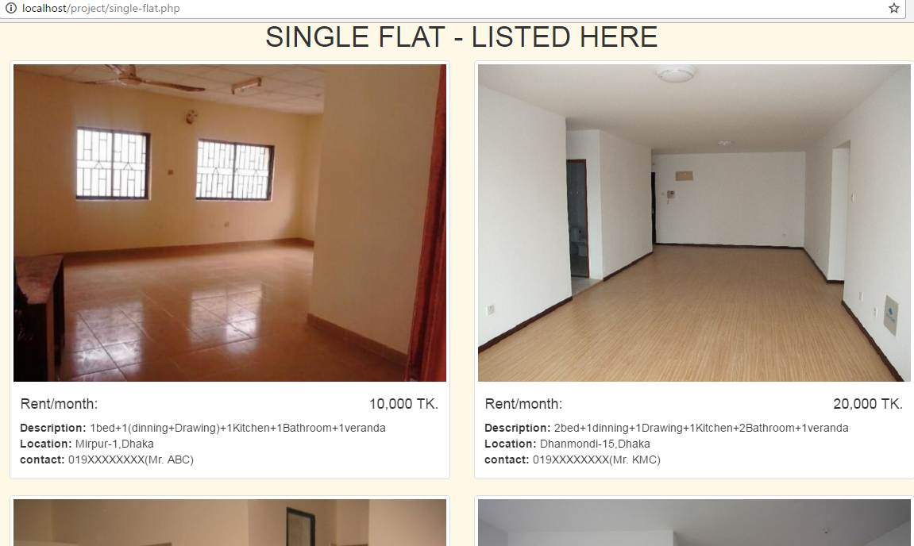**8.1.2 House Category Sample:**

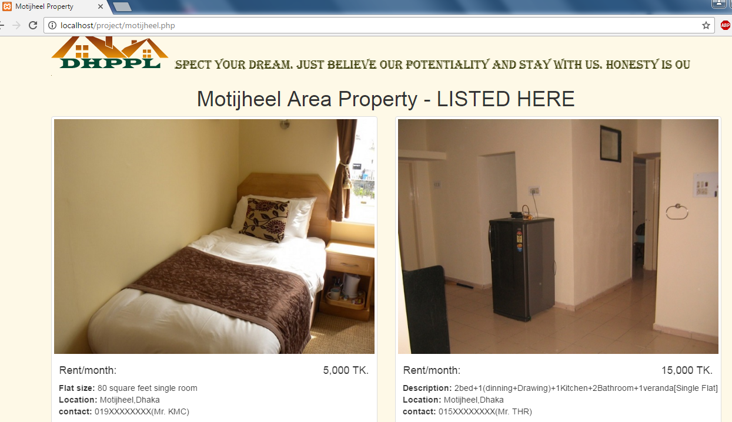**8.1.3 A Sample of Property Search by Area:**

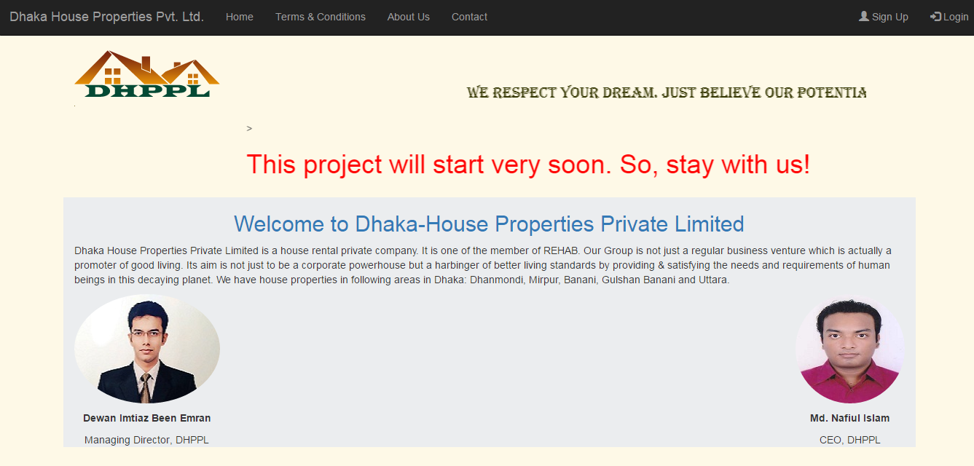**8.1.4 No Property Found Page:**

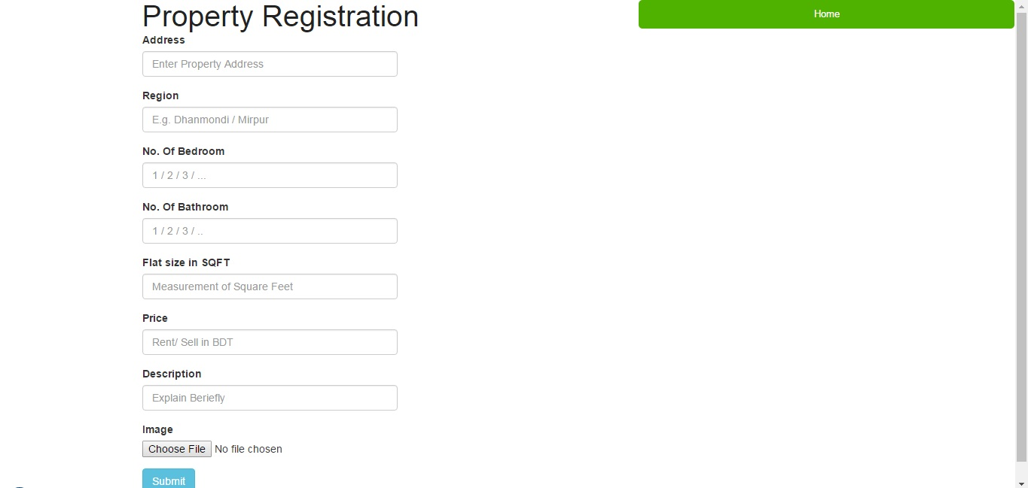**8.1.5 Property Registration:**

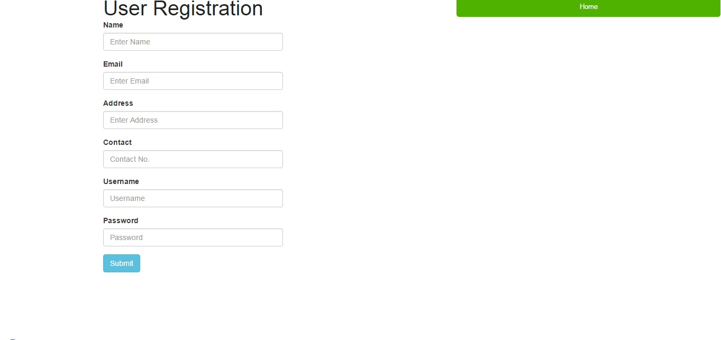**8.1.6 User Registration:**

**9. Conclusion and Discussion**

This is not the complete version of the system. This is beta version. Complete version will release very soon.

In whole procedure to prepare project, we first gather the requirement of the project and decide the time schedule. After planning we design the documentation of project. After the design we generate the code of system. In design the code we do the error estimation and effort estimation. If error is occur then solve it. Finally when code is designed then test the project and decide the cost of project.

The project is for the mass people. So it should be very easy to use and user friendly. We also concern about the security purpose because this is online based system. There are some terms and conditions for all kind of users because this can be platform of business dealing, the platform which may concern about Rental House Management System property.

**10. References/Bibliography**

**Author:**

* Software Engineering: A Practioner’s Approach 6th edition by Roger Pressman, McGraw Hill international edition.
* The Object Oriented Approach Concepts, System Development and Modeling with UML, Satzinger, Orvik, 2nd edition.

**Web Links:**

* [www.google.com.bd](http://www.google.com.bd)
* [www.youtube.com](http://www.youtube.com)
* [www.wikipedia.com](http://www.wikipedia.com)
* [www.slideshare.net](http://www.slideshare.net)
* [www.tutorialspoint.com/laravel/](http://www.tutorialspoint.com/laravel/)
* <https://laravel.com/docs/4.2/quick>
* <https://dotdev.co/step-by-step-guide-to-building-your-first-laravel-application-8396503d88#.po2g9l2zi>
* <http://html.com/>
* [www.w3schools.com](http://www.w3schools.com)
* [www.project-management-basics.com](http://www.project-management-basics.com)
* [www.real-estate-management-system.nic.in](http://www.real-estate-management-system.nic.in)
* <http://www.fillster.com/htmlcodes/marquees.html>